|  |  |
| --- | --- |
| school-learn-study-hat-graduate-512.png | ***Study*** |

Read session 11.1, 11.2, 11.3, 11.4, 11.5, 11.6, 11.8, 11.9, 11.12 of the following book:

<http://www.ict.ru.ac.za/Resources/cspw/thinkcspy3/thinkcspy3.pdf>

And then answer the following questions:

* What is nested list?

List chứa một hoặc nhiều list trong nó gọi là **nested list**.

* Can a list store both integers and strings in it?

List có thể cùng chứa kiểu interger và kiểu string trong nó

* Do exercise 1, 2 in this chapter (note: these include sub-exercises, so you better start early)

Bài 1

* Kết quả khi thực hiện câu lệnh >>> list(range(10, 0, -2)) :

10, 8, 6, 4, 2]

* Khi thực hiện câu lệnh trên với start < stop và step < 0 sẽ có kết quả là:

>>> list(range(10, 20, -2))

[]

* Mối quan hệ giữa Start, Stop và Step :

Thực hiện bước nhảy với điểm đầu là Start, điểm cuối là Stop với bước nhảy là Step.

Bài 2

* Đoạn code vừa rồi chỉ tạo một instance, hai biến alex và tess cùng chỉ vào một instance duy nhất. Do đó khi ta thay đổi giá trị color của alex thì đồng thời giá trị này của tess cũng đổi theo.

|  |  |
| --- | --- |
| http://www.bestappsforkids.com/wp-content/uploads/2012/04/save-turtle.png | ***Turtle exercises*** |

Given the following list: colors = ['red', 'blue', 'brown', 'yellow', 'grey']

Using turtle to draw the following shapes:

|  |  |
| --- | --- |
|  | 2. |
|  |  |

Hint:

Google:

“turtle stroke color”

“turtle fill color”

|  |  |
| --- | --- |
| 6iporAnbT.jpg | ***Serious exercises*** |

1. Finish CRUD exercise in class, simulate a clothes shop

Welcome t’o our shop, what do you want (C, R, U, D)? C

Enter new ===item: Jeans

Our items: T-Shirt, Sweater, Jeans

Welcome to our shop, what do you want (C, R, U, D)? R

Our items: T-Shirt, Sweater, Jeans

Welcome to our shop, what do you want (C, R, U, D)? U

Update position? 1

New item? Skirt

Our items: T-Shirt, Skirt, Jeans

Welcome to our shop, what do you want (C, R, U, D)? D

Delete position? 2

Our items: T-Shirt, Skirt, Jeans

Handle the exceptions (upper, lower case, index out of range) yourself

1. You are a shepherd who owns a flock of sheep

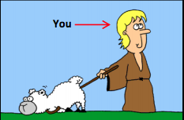

Each of your sheep of your flock has different size:

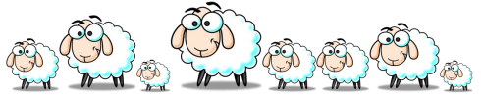

2.1 Create a list to represent the sizes of your flock, using list, and print all of your flock size, expected screen output:

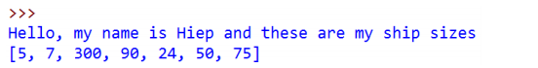

2.2. At the end of each month, you have to choose one and only one sheep to shear and thus you want to choose the biggest one to maximize your profit. Write a program to search for the biggest sheep in your list:

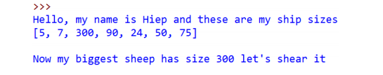

2.3. When your biggest sheer, its size will return to the default size, which is 8.

Print out your ship size after shearing the biggest one:

Hint: Google “Python List index function”

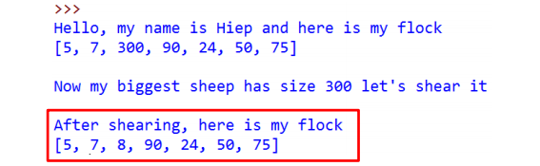

2.4 In the following month, EVERY sheep in your flock grow, they have their size increased by 50. Print them out

Hint: Ask TA if you need help

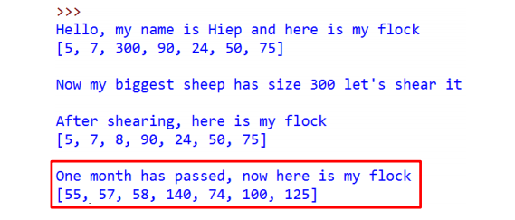

2.5. Let do this for 4 months (or as long as you want):

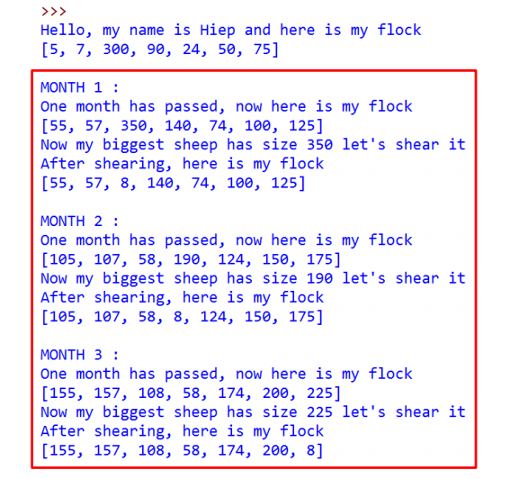

2.6 After day by day shearing shapes, you became bored. You want to sell your flock to travel the world. In order to have fair trade, you must now calculate the total size of your sheep and then the expected money you can get from your flock before going to the market. Write a program to calculate the total size of your sheep as well as the money you would have. Expected screen output:

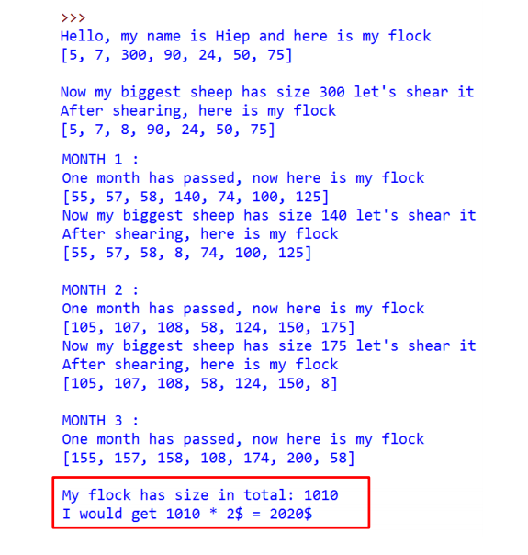

|  |  |
| --- | --- |
| system_config_boot.png | ***Tools preparation*** |

Learn how to upload file to github.com by learning the following steps:

* Clone your repository
* Submit your files
* Push you files

Video tutorial: <https://www.youtube.com/watch?v=Yq32Ifx0bXw>

From now on, using git to commit your homework is a MUST, no more .zip, Google Drive, DropBox …